Asia-China-Coin EBAY-Small items

Order details Printer friendly page

Sold by

[holypardom193](http://myworld.ebay.com/holypardom193) ( [1319](http://feedback.ebay.com/ws/eBayISAPI.dll?ViewFeedback&userid=holypardom193)  )

+ Show additional actions

Delivery package 1 of 1

Estimated delivery Thursday, Jan 2, 2014 - Friday, Jan 10, 2014

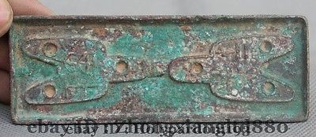

[115MM China Chinese Bronze Money Cion *015](http://www.ebay.com/itm/321267120503)

Item price

$48.00

Quantity

1

Item number

321267120503

Shipping service

ePacket delivery from China

[Leave feedback](http://feedback.ebay.com/ws/eBayISAPI.dll?LeaveFeedbackShow&useridfrom=802-867&useridto=holypardom193&item=321267120503&transactid=1203110083011) [Contact seller](http://contact.ebay.com/ws/eBayISAPI.dll?FindAnswers&frm=3998&iid=321267120503&redirect=0&requested=holypardom193) [Return item](http://return.ebay.com/ws/eBayISAPI.dll?ResolveReturn&eventName=viewSelectedItem&TransactionId=1203110083011&ItemId=321267120503)

Sold by

[cnrelics](http://myworld.ebay.com/cnrelics) ( [18](http://feedback.ebay.com/ws/eBayISAPI.dll?ViewFeedback&userid=cnrelics)  )

+ Show additional actions

Delivery package 1 of 1

Estimated delivery Friday, Jan 10, 2014 - Friday, Feb 7, 2014

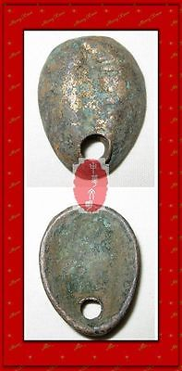

[VINTAGE SHANG ZHOU RIVER FISHER MAN CURRENCY MONEY GILT BRONZE SEASHELL COIN包金贝](http://www.ebay.com/itm/151187445070)

Item price

$9.99

Quantity

1

Item number

151187445070

Shipping service

Economy Shipping from outside US

[Leave feedback](http://feedback.ebay.com/ws/eBayISAPI.dll?LeaveFeedbackShow&useridfrom=802-867&useridto=cnrelics&item=151187445070&transactid=0) [Contact seller](http://contact.ebay.com/ws/eBayISAPI.dll?FindAnswers&frm=3998&iid=151187445070&redirect=0&requested=cnrelics) [Return item](http://return.ebay.com/ws/eBayISAPI.dll?ResolveReturn&eventName=viewSelectedItem&TransactionId=0&ItemId=151187445070)

Sold by

[hzfeng197388](http://myworld.ebay.com/hzfeng197388) ( [734](http://feedback.ebay.com/ws/eBayISAPI.dll?ViewFeedback&userid=hzfeng197388)  )

+ Show additional actions

Delivery package 1 of 1

Estimated delivery Thursday, Jan 2, 2014 - Friday, Jan 10, 2014

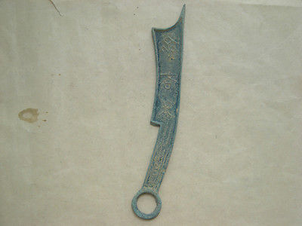

[Vintage China Ancient Bronze Intermediate knife-shaped Coin Statue](http://www.ebay.com/itm/271344271425)

Item price

$0.99

Quantity

1

Item number

271344271425

Shipping service

ePacket delivery from China

[Leave feedback](http://feedback.ebay.com/ws/eBayISAPI.dll?LeaveFeedbackShow&useridfrom=802-867&useridto=hzfeng197388&item=271344271425&transactid=0) [Contact seller](http://contact.ebay.com/ws/eBayISAPI.dll?FindAnswers&frm=3998&iid=271344271425&redirect=0&requested=hzfeng197388) [Return item](http://return.ebay.com/ws/eBayISAPI.dll?ResolveReturn&eventName=viewSelectedItem&TransactionId=0&ItemId=271344271425)

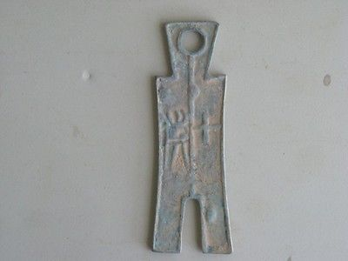

[Vintage China Ancient Exorcise Bronze word base currency Figures & Statues](http://www.ebay.com/itm/271344496598)

Item price

$0.99

Quantity

1

Item number

271344496598

Shipping service

ePacket delivery from China

[Leave feedback](http://feedback.ebay.com/ws/eBayISAPI.dll?LeaveFeedbackShow&useridfrom=802-867&useridto=hzfeng197388&item=271344496598&transactid=0) [Contact seller](http://contact.ebay.com/ws/eBayISAPI.dll?FindAnswers&frm=3998&iid=271344496598&redirect=0&requested=hzfeng197388) [Return item](http://return.ebay.com/ws/eBayISAPI.dll?ResolveReturn&eventName=viewSelectedItem&TransactionId=0&ItemId=271344496598)

Sold by

[bcculture](http://myworld.ebay.com/bcculture) ( [76](http://feedback.ebay.com/ws/eBayISAPI.dll?ViewFeedback&userid=bcculture)  )

+ Show additional actions

Delivery package 1 of 1

Estimated delivery Friday, Jan 10, 2014 - Friday, Feb 7, 2014

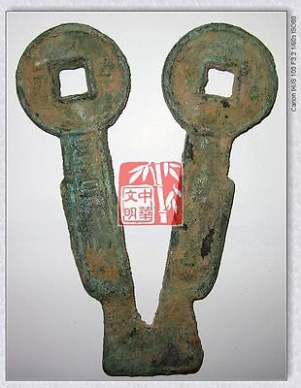

[VINTAGE CHINA HAN KINGDOM XIN POLICY ￥500MONEY BRONZE FALCHION-SHAPE COIN契刀五百4"](http://www.ebay.com/itm/251402127939)

Item price

$9.99

Quantity

1

Item number

251402127939

Shipping service

Economy Shipping from outside US

[Leave feedback](http://feedback.ebay.com/ws/eBayISAPI.dll?LeaveFeedbackShow&useridfrom=802-867&useridto=bcculture&item=251402127939&transactid=0) [Contact seller](http://contact.ebay.com/ws/eBayISAPI.dll?FindAnswers&frm=3998&iid=251402127939&redirect=0&requested=bcculture) [Return item](http://return.ebay.com/ws/eBayISAPI.dll?ResolveReturn&eventName=viewSelectedItem&TransactionId=0&ItemId=251402127939)

Sold by

[yj88669](http://myworld.ebay.com/yj88669) ( [71](http://feedback.ebay.com/ws/eBayISAPI.dll?ViewFeedback&userid=yj88669)  )

+ Show additional actions

Delivery package 1 of 1

Estimated delivery Thursday, Jan 2, 2014 - Friday, Jan 10, 2014

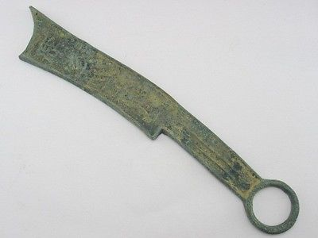

[Chinese bronze trade Tools , mystery of the poetry,knife currency](http://www.ebay.com/itm/261352630430)

Item price

$6.99

Quantity

1

Item number

261352630430

Shipping service

ePacket delivery from China

[Leave feedback](http://feedback.ebay.com/ws/eBayISAPI.dll?LeaveFeedbackShow&useridfrom=802-867&useridto=yj88669&item=261352630430&transactid=0) [Contact seller](http://contact.ebay.com/ws/eBayISAPI.dll?FindAnswers&frm=3998&iid=261352630430&redirect=0&requested=yj88669) [Return item](http://return.ebay.com/ws/eBayISAPI.dll?ResolveReturn&eventName=viewSelectedItem&TransactionId=0&ItemId=261352630430)

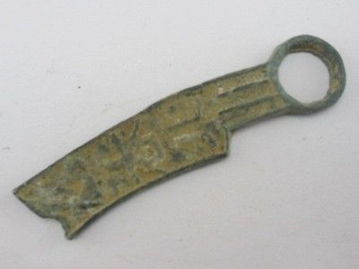

[Chinese bronze trade Tools , mystery of the poetry,small knife currency](http://www.ebay.com/itm/261352631413)

Item price

$3.99

Quantity

1

Item number

261352631413

Shipping service

ePacket delivery from China

[Leave feedback](http://feedback.ebay.com/ws/eBayISAPI.dll?LeaveFeedbackShow&useridfrom=802-867&useridto=yj88669&item=261352631413&transactid=0) [Contact seller](http://contact.ebay.com/ws/eBayISAPI.dll?FindAnswers&frm=3998&iid=261352631413&redirect=0&requested=yj88669) [Return item](http://return.ebay.com/ws/eBayISAPI.dll?ResolveReturn&eventName=viewSelectedItem&TransactionId=0&ItemId=261352631413)

Sold by

[yj88669](http://myworld.ebay.com/yj88669) ( [71](http://feedback.ebay.com/ws/eBayISAPI.dll?ViewFeedback&userid=yj88669)  )

+ Show additional actions

Delivery package 1 of 1

Estimated delivery Monday, Dec 30, 2013 - Wednesday, Jan 8, 2014

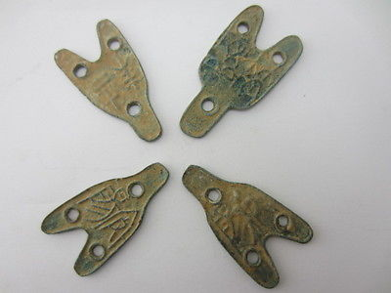

[Ancient Chinese bronze tools trading ,Carving ancient font ,three hole cloth 三孔布](http://www.ebay.com/itm/261351696302)

Item price

$9.99

Quantity

1

Item number

261351696302

Shipping service

ePacket delivery from China

[Leave feedback](http://feedback.ebay.com/ws/eBayISAPI.dll?LeaveFeedbackShow&useridfrom=802-867&useridto=yj88669&item=261351696302&transactid=0) [Contact seller](http://contact.ebay.com/ws/eBayISAPI.dll?FindAnswers&frm=3998&iid=261351696302&redirect=0&requested=yj88669) [Return item](http://return.ebay.com/ws/eBayISAPI.dll?ResolveReturn&eventName=viewSelectedItem&TransactionId=0&ItemId=261351696302)

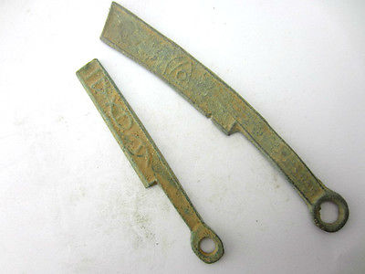

[Two different face value Ancient Chinese bronze tools trading knife currency](http://www.ebay.com/itm/261351703542)

Item price

$6.99

Quantity

1

Item number

261351703542

Shipping service

ePacket delivery from China

[Leave feedback](http://feedback.ebay.com/ws/eBayISAPI.dll?LeaveFeedbackShow&useridfrom=802-867&useridto=yj88669&item=261351703542&transactid=0) [Contact seller](http://contact.ebay.com/ws/eBayISAPI.dll?FindAnswers&frm=3998&iid=261351703542&redirect=0&requested=yj88669) [Return item](http://return.ebay.com/ws/eBayISAPI.dll?ResolveReturn&eventName=viewSelectedItem&TransactionId=0&ItemId=261351703542)

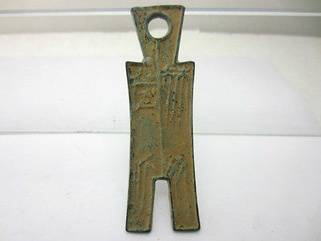

[Ancient Chinese bronze tools trading turouser big currency big pendant](http://www.ebay.com/itm/261351704709)

Item price

$6.99

Quantity

1

Item number

261351704709

Shipping service

ePacket delivery from China

[Leave feedback](http://feedback.ebay.com/ws/eBayISAPI.dll?LeaveFeedbackShow&useridfrom=802-867&useridto=yj88669&item=261351704709&transactid=0) [Contact seller](http://contact.ebay.com/ws/eBayISAPI.dll?FindAnswers&frm=3998&iid=261351704709&redirect=0&requested=yj88669) [Return item](http://return.ebay.com/ws/eBayISAPI.dll?ResolveReturn&eventName=viewSelectedItem&TransactionId=0&ItemId=261351704709)

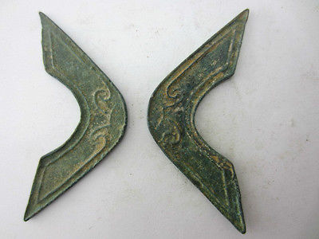

[Two Ancient Chinese bronze tools trading bridge style currency ancient font](http://www.ebay.com/itm/261351711164)

Item price

$8.99

Quantity

1

Item number

261351711164

Shipping service

ePacket delivery from China

[Leave feedback](http://feedback.ebay.com/ws/eBayISAPI.dll?LeaveFeedbackShow&useridfrom=802-867&useridto=yj88669&item=261351711164&transactid=0) [Contact seller](http://contact.ebay.com/ws/eBayISAPI.dll?FindAnswers&frm=3998&iid=261351711164&redirect=0&requested=yj88669) [Return item](http://return.ebay.com/ws/eBayISAPI.dll?ResolveReturn&eventName=viewSelectedItem&TransactionId=0&ItemId=261351711164)